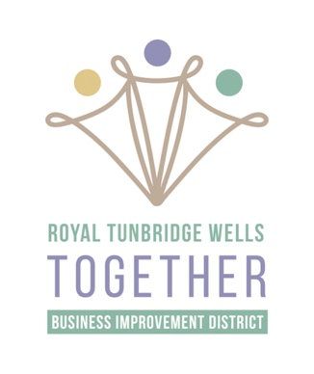
RTW Together Business Improvement District
Board Director: Application

Being a Director of Royal Tunbridge Wells Together Business Improvement District is an important role that carries responsibilities. The BID is funded by more than 600 businesses of varying sizes, and Directors should be aware that the BID must be accountable and transparent to the levy paying businesses and always act in the best interest of the town as a whole, not for individual business needs. The BID seeks to drive footfall, vibrancy and business activity in the BID area and increase overall vitality in the town centre.
Please note: Directors should adhere to the Terms of Reference that accompany this application form – please read these before completing the application so that you are fully aware of expectations, then sign this form at the bottom to confirm that you are willing to fully commit and adhere to these terms as a Board Director.
Full Name (including any middle names)
Date of Birth
Nationality
Usual Residential Address
Correspondence Address
Email
Telephone
Business you represent
Sector or geographical area you represent
Please list any relevant skills and experience that you can contribute to the Board

Please outline why you wish to become a Board Director for RTWT:

Board Director Nominations
Please provide details of two nominees, supporting your application to become a RTW Together board Director. These must be representatives of levy paying businesses within the BID area.
First nomination
Name:
Business:
Second nomination
Name:
Business:

- Please confirm that you have read and understood the Terms of Reference (signature):

________________________________________________________________________________

- Please confirm that you are willing to commit to the expectations of Board Directors, as specified in the Terms of Reference (signature):
_____________________________________________________________________________

Please send applications to biddirector@rtwtogether.com

