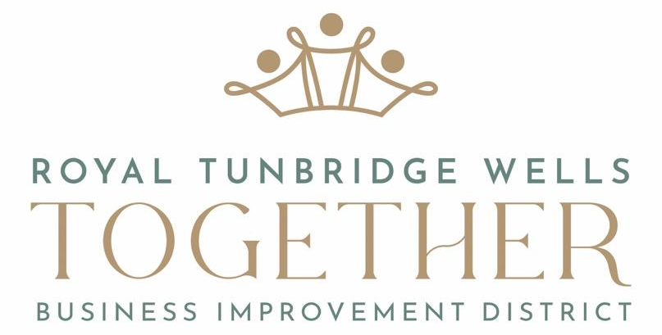

2023/2024 Grant Programme

What are we
Royal Tunbridge Wells Together is the organisation behind the Business Improvement District in Royal Tunbridge Wells. It is a non-for-profit Community Interest Company based in the town, led by a Chief Exec and overseen by a volunteer board of directors made up from local businesses. It is funded through a BID levy scheme that every eligible business pays into.

What is our purpose
Our purpose is to serve our levy payers in any way that may support them, be that through increasing trade, lowering costs or generally improving the environment for them. One of our core priorities designed to serve that purpose, is to run or support the running of events which will benefit businesses.

What are levy payers
Every business within the BID Geographic area (on last page) which is based within a property that has a rateable value higher than £15k, is required to pay a small supplementary levy on their business rates. These are the organisations RTW Together is primary here to support.

Why do we offer grants
Our grant scheme is designed to support our levy payers by generating revenue for them. This will primarily be by bringing people into the town for an event or project that may then create custom for them whilst they are in town but may do so more directly (e.g. by purchasing products or services from them). We also aim to increase the recognition of RTW as an exciting, cultural destination that people should visit.

What grants do we offer
We offer grants from £500-£5,000 to support one off projects. In addition to large scale festivals and regular street markets we encourage smaller grant requests for reduced scale events. The grants also now support capital infrastructure for existing or potential venues looking to improve their offering and bring in more visitors to the town.

The funds are not to cover general overheads for organisations and the award of a grant does not mean that future grants will be awarded – i.e. each grant fund and assessment is distinct from the prior one.

Who do we offer grants
Our grant scheme is designed to help individuals, organisations, charities, businesses and venues however if they are profit making then they must demonstrate why the grant is needed and wont simply increase the profit for an organisation or individual.

We encourage applications from individuals and organisations who have not applied before and they are welcome to seek guidance from RTW Together if they are not familiar with making applications.

Anyone is welcome to contact RTW Together to ask about our grant schemes
Grant Guidance Notes

Grant Fund | 2023/23 Budget  Allocation | Deadline for  Applications | Assessment of Applications
Event Grants | £32,000 | 10am 1st May | 5th May
Markets Support | £12,000 | 10am 1st May | 5th May
Attraction Grants | £12,000 | 10am 5th Jun | 16th Jun

On the basis of an application, RTW Together may choose to approve, deny a request or offer a partial award. Please hand in a signed paper copy in person, send by post to RTW Together, 52 High Street, Tunbridge Wells, Kent or email to biddirector@rtwtogether.com.

Application Details
- If it would be easier, a separate paper may be submitted as part of your application answering some or all of the questions as long as each question is fully answered
- All applications will be responded to whether successful or not
- If there are any funds remaining, a second round will take place later in the year
- 75% of the grant will be awarded within 10 working days after the award is made
- 25% of the grant will be awarded within 10 working days of receipt of a completed evaluation form
- If any of the conditions are broken then you will not receive any further funding and will be unable to make any future applications
- Grant awards are for the set amount specified and will not be subject to additional VAT claims
- Only one application can be made per venue for attraction grants.
- Applications will be primarily judged on the following criteria (although the BID may alter its assessment criteria at its discretion):-
Figure applied for | Ratio applied*
Number of attendees brought to town | 7 points
Likelihood of project taking place | 4 points
Likelihood of success of level proposed | 4 points
Amount of money invested with levy payers | 4 points
Level of Business Engagement with levy payers | 4 points
Promoting RTW as a valued destination | 4 points
Promotion of RTW Together and its support | 3 points
* Larger grant requests will have their score adjusted downwards to balance the ROI of the grant

- Assessments will consider the success of previous projects when determining criteria scoring
- RTW Together reserves the right to decline applications which it considers may harm the reputation of the BID or bring it into disrepute
- Events that take place primarily outside of BID area are highly unlikely to be awarded a grant
- Attraction grants are unlikely to be awarded to venues owned by a public sector organisation
Grant Application Form
What are you applying for?

Event Grant (Fund to support unique events/festivals - £500-£5000)

Markets Support (Fund to support street markets – £500-£3000)

Attraction Grant (Fund to support existing and potential venues – £500-£3000)

What is your organisation’s name? _________________________________________

What is the name of your project? _________________________________________

How much are you applying for? _________________________________________

Please provide a list of Levy Payers who are supportive of your project*
The applicant cannot be one of the levy payers listed below

No. | Business Name | Contact Name & Email
1 (must be local to the project)
2

3 (only needed if applying for £2k+)
4 (only needed if applying for £3k+)
5 (only needed if applying for £4k+)
*Most businesses within the BID area are levy payers (unless very small), ask RTW Together if unsure

Applicant Details
Name of applicant

Email Address

Phone Number
Address of organisation or applicant
Project Details

Please give a brief Description of Project
Please include, what you would like to do, what is its purpose and who will benefit from it?
 | Project Details | What % (approx.) of this activity will take place in the BID area*
When and where will your project take place?

How long will the project last/what timings are you planning (approx)?
How many attendees do you expect to you attend?
For attraction grants use venue annual attendance
*Please see map on last page

How will you promote your project?

If this is a profit generating project, please justify why this project should be supported?
Finances
What is the total budget for this project?

What confirmed funding have you been pledged for this project from other sources e.g. grants?
Please provide details and amounts

What other funding are you still applying for this project?
Please provide details and amounts

What earned income (ticket income, sponsorship, stall fees etc) do you intend to raise for this project?
Please provide details and amounts

What are your costs for the event?
Please provide approximate details and amounts

Or alternatively share a budget separately.

Applicant Experience

Has your organisation run this or a similar project before?
(Please provide details of any previous successes and attendance figures)

What is the relevant experience of the key people running this project for delivering a project of this nature?
RTW Business Support

What proportion of your total budget spend do you plan to spend locally with BID levy payers?*
Please provide some examples, this can include hospitality, equipment supplies, marketing or finance support.
*Most businesses within the BID area are levy payers (unless very small), ask RTW Together if unsure

How will you interact with local businesses to promote them?
E.g. running a promotional trail into their businesses. Please ask RTW Together for feedback.

RTW Together Priorities

Please identify how your project will support and enhance the reputation of Royal Tunbridge Wells town centre as a valued destination

How will you promote RTW Together to the business community and its investment into this project? Please provide some examples both to businesses and general public
Payments

What is your organisation’s
bank account name __________________________________

bank account number __________________________________

sort code __________________________________

Grant award conditions

By applying for this grant you confirm
- you have been truthful to the best of your ability
- grants will only cover expenditure yet to be incurred
- you will deliver the project/spend the money by 31st December 2023 (unless otherwise agreed)
- you have a UK Bank Account for the award to be deposited into
- you will run a safe project including producing necessary risk assessments
- your organisation will acquire all necessary relevant insurance and licenses
- the grant will only cover a maximum of 50% of the total budget for the project
- within 10 days of being awarded a grant you will provide RTW Together with
  - a 30 word summary of the project
  - a short quote supporting the project
  - a picture and/or logo of the project
- you will provide us with a completed evaluation form within 1 month of the project completing
- you will return awarded funds if the applied for project is cancelled (unless agreed otherwise by RTW Together)
- you will credit the BID with
  - our logo on any physical publicity (including flyers and banners)
  - our logo on any digital marketing materials (including website, emails and adverts)
  - being a sponsor in any press releases and interviews
- you have the authority to and hereby give consent for the BID to use any images, quotes or feedback for promotional or other purposes

I have read and understood the above terms.

Signature ___________________________________

Name ___________________________________

Date ___________________________________

Grant Evaluation Form
What is your organisation’s name? _________________________________________

What was the name of your project? _________________________________________

How much were you awarded? _________________________________________

Please give a brief Description of how the Project went
Please include, what went right and what went wrong?

 | Project Details | What % (approx.) of this activity took place in the BID area
How many attendees do you believe attended?
For attraction grants use venue annual attendance

Levy Payer Responses
You should use the same levy payers that you referred to in your application

No. | Name | Quote – Please provide a quote from them on their view of the project and whether they thought it was a good BID investment
1

2

3 (only needed if applying for £2k+)
4 (only needed if applying for £3k+)
5 (only needed if applying for £4k+)
RTW Business Support

What proportion of your total budget spend did you spend locally with BID levy payers?*
Please provide some examples, this can include hospitality, equipment supplies, marketing or finance support.

How did you interact with local businesses to promote them?
E.g. running a promotional trail into their businesses

RTW Together Priorities

How did your project support and enhance the reputation of Royal Tunbridge Wells town centre as a valued destination?

How did you promote RTW Together to the business community and its investment into this project?
Please provide some examples both to businesses and general public

Please also provide at least 3 copies of any promotional flyers and 3 pictures of the event as attachments.

RTW Together BID Geographic Area

